**DCAKE**

Delicious to the last pieces

***Project Group Members***

|  |  |
| --- | --- |
| ***Student Id*** | ***Student Name*** |
| *Student1274240* | *Abu Hurairah Khan* |
| *Student1249941* | *Mubeen Ahmed* |
| *Student1274625* | *Syed Hammad Ali* |

***Curriculum: 6740***

***Batch: 2009g1***

***Faculty: sir Fahad***

***Co ordinator: miss Yumna***

***Screen shoots***

1. ***home page***

***Navbar***



***Content***



***footer***

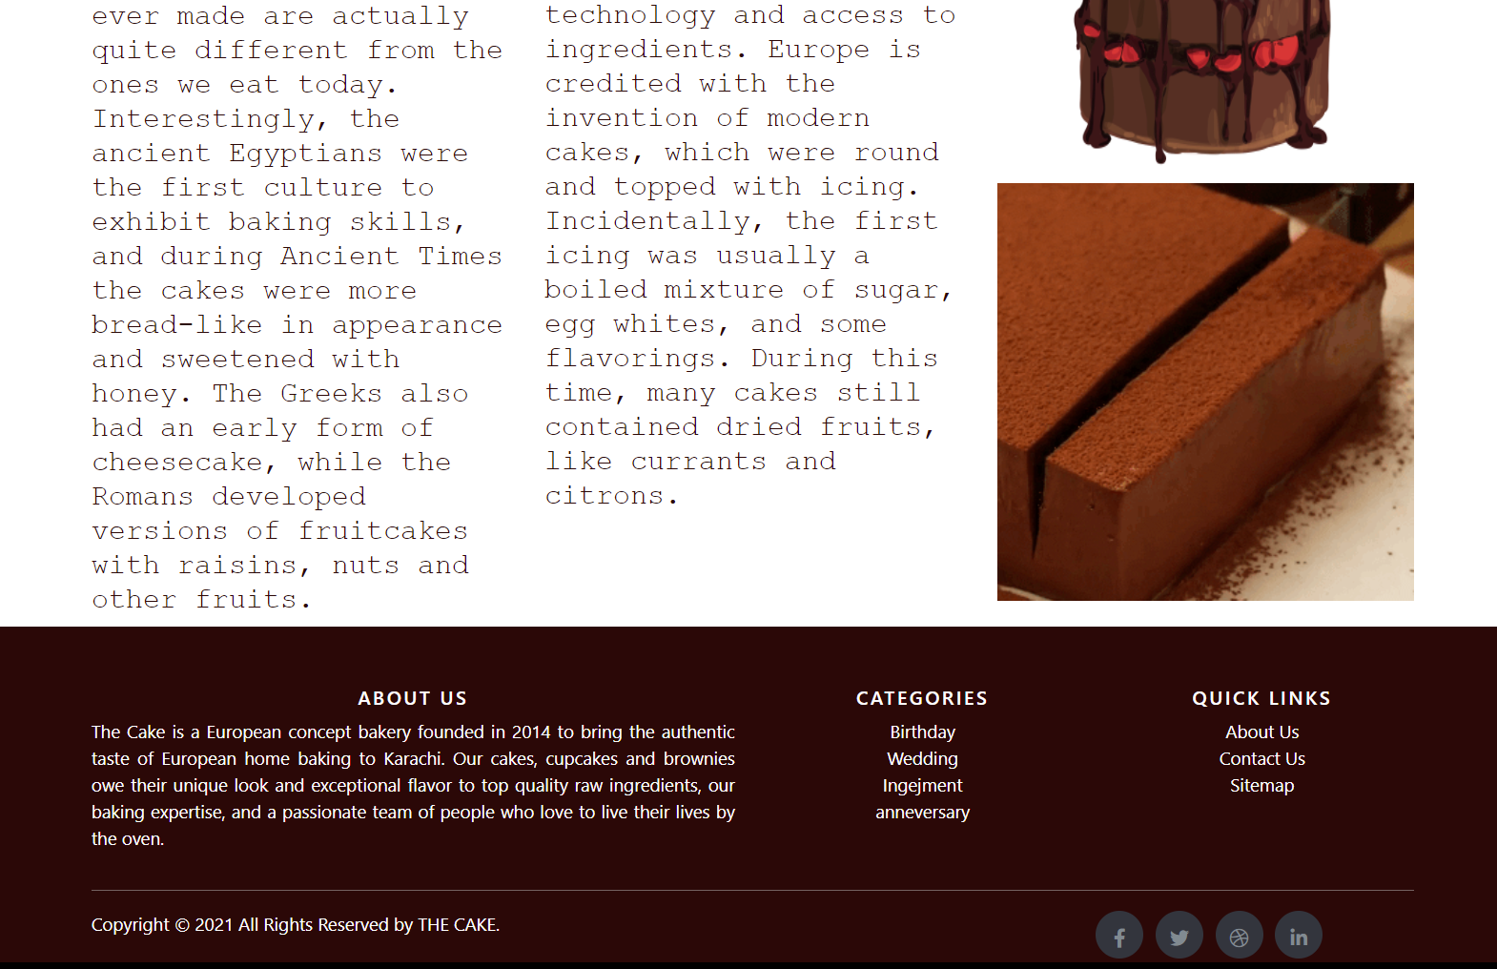

1. ***about us***



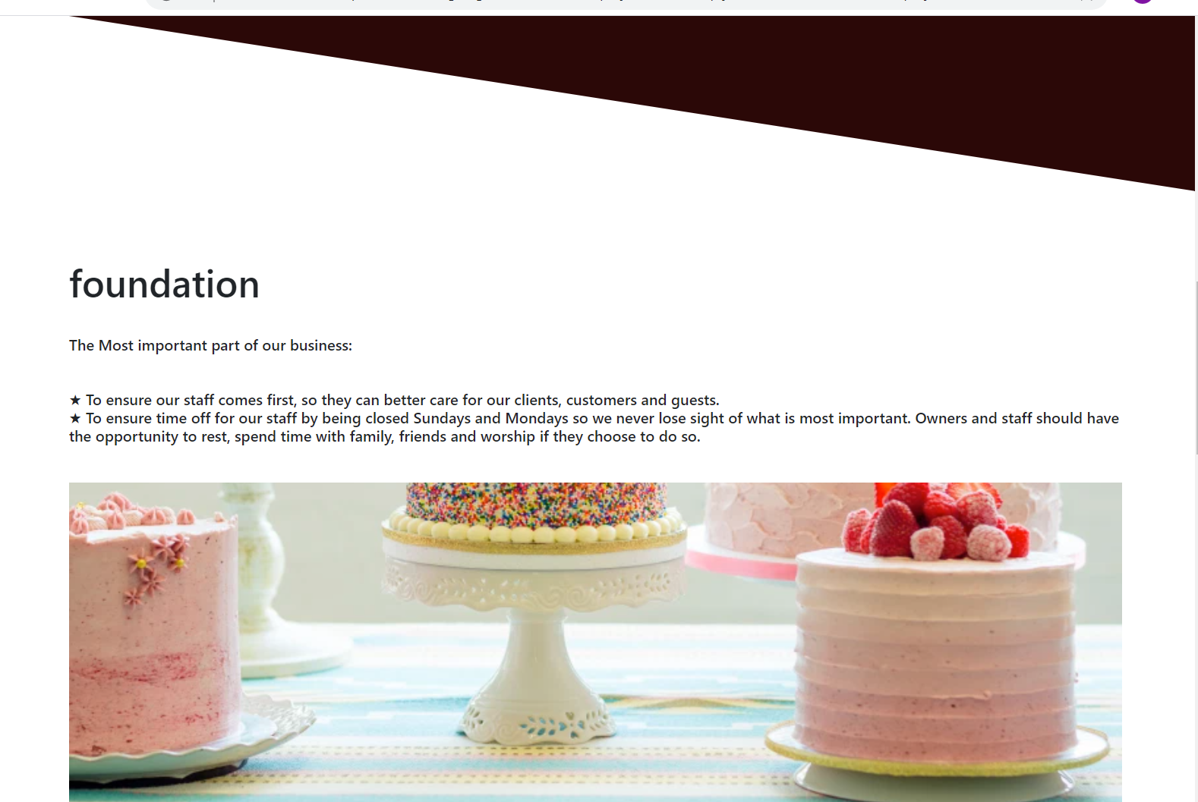

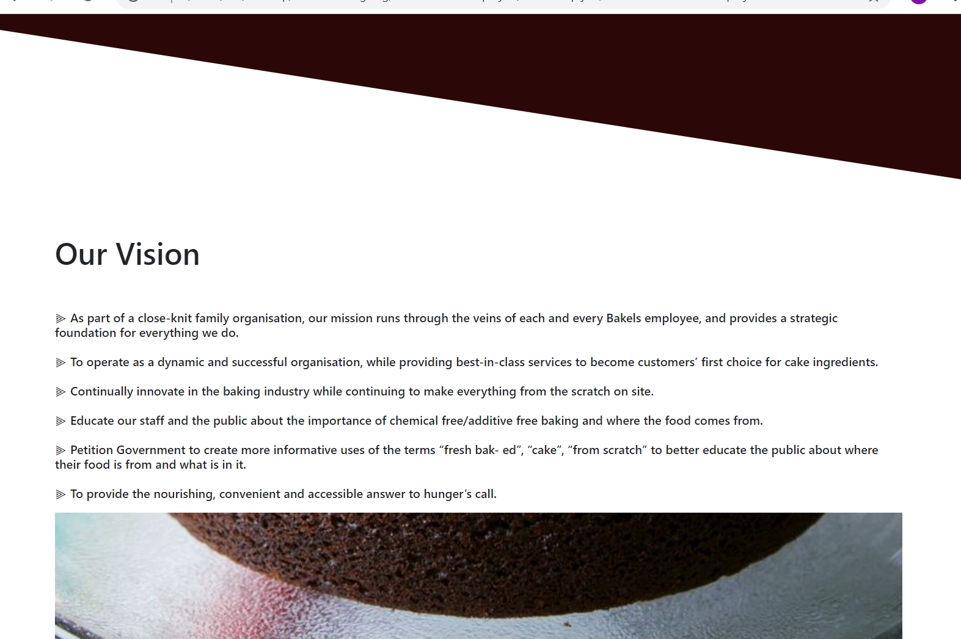

1. contact us

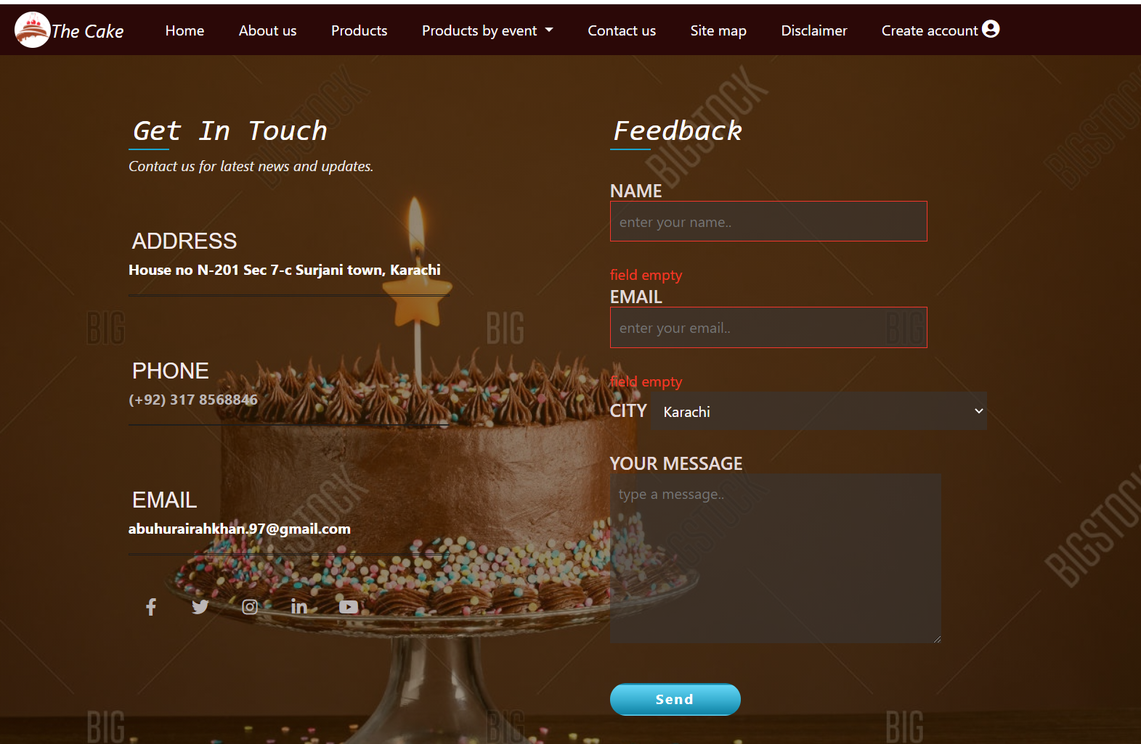

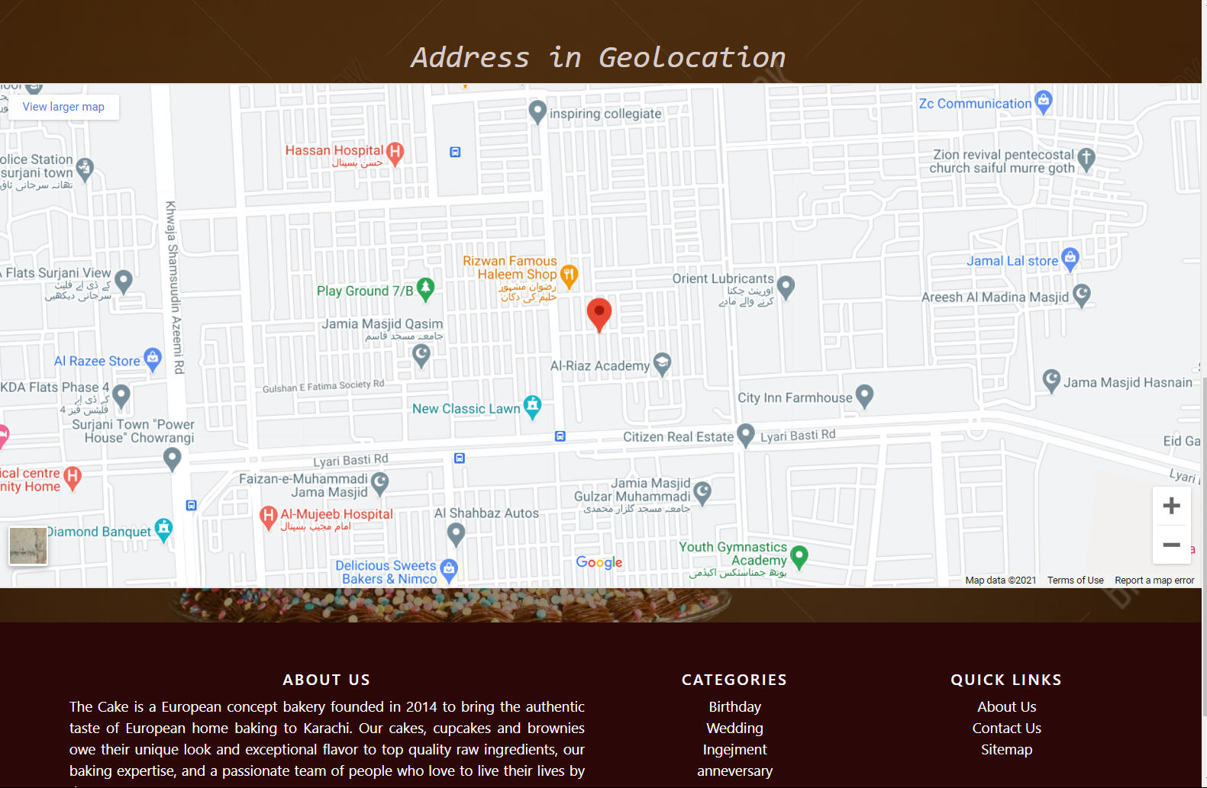

1. disclaimer



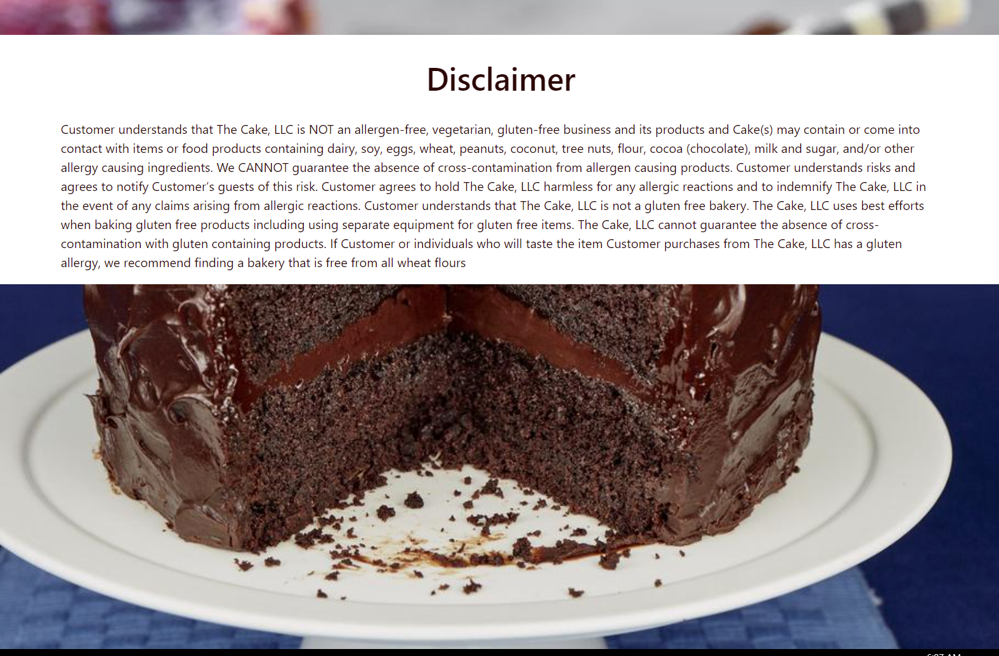

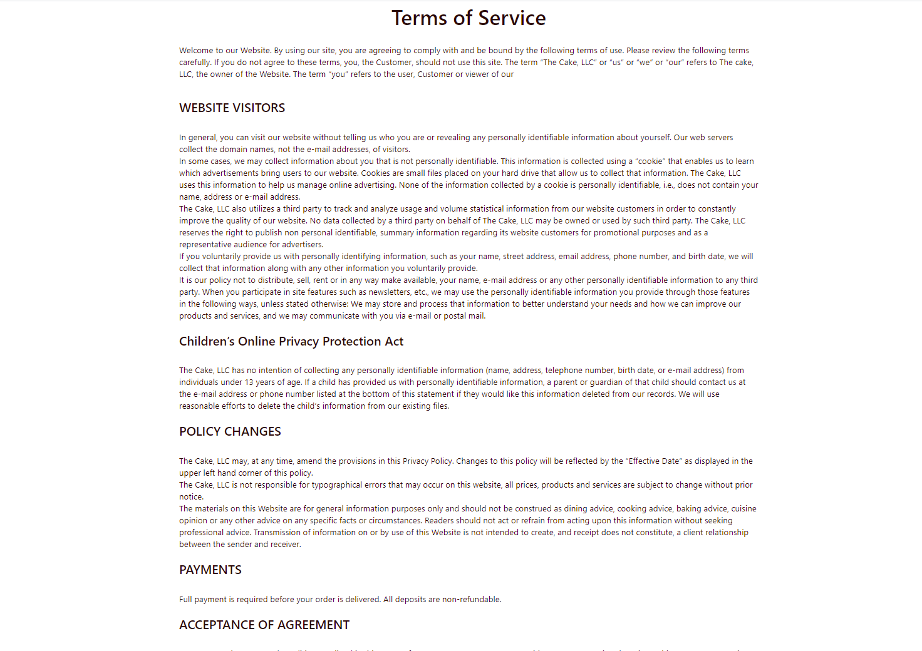

1. create account

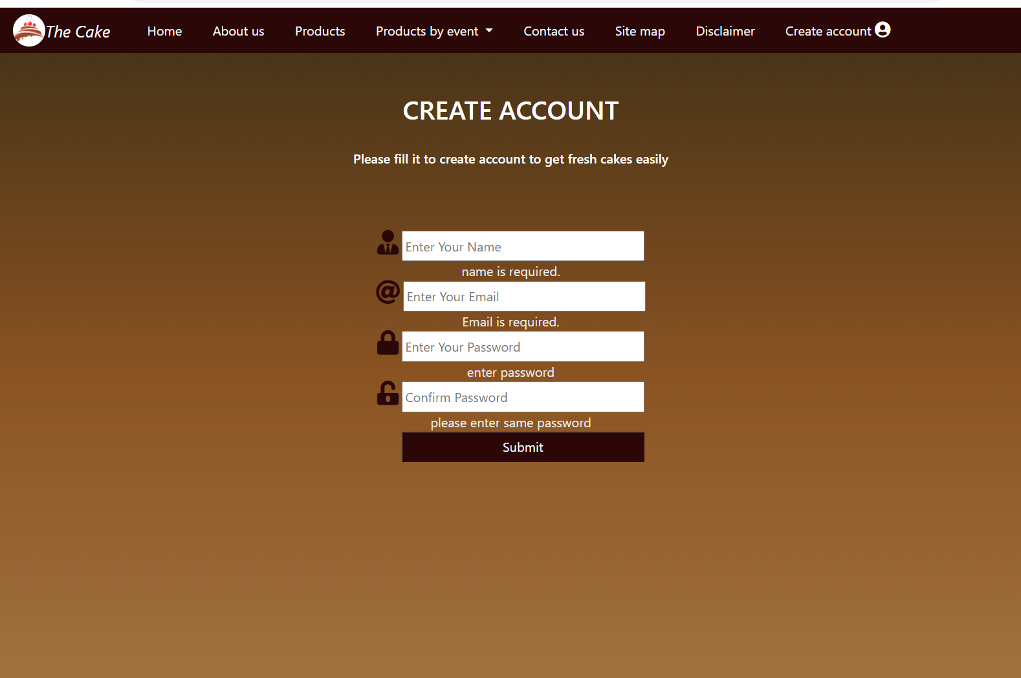

1. SITE MAP

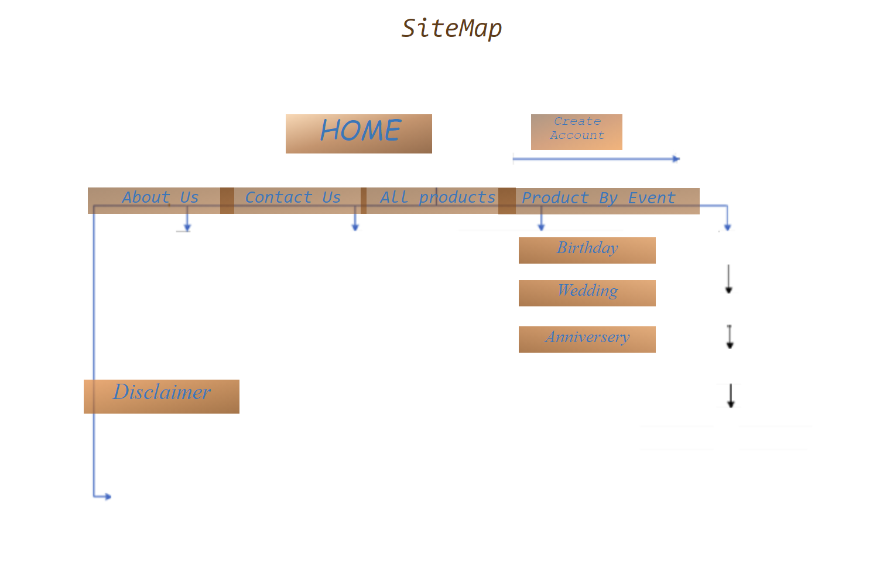

**7.products**

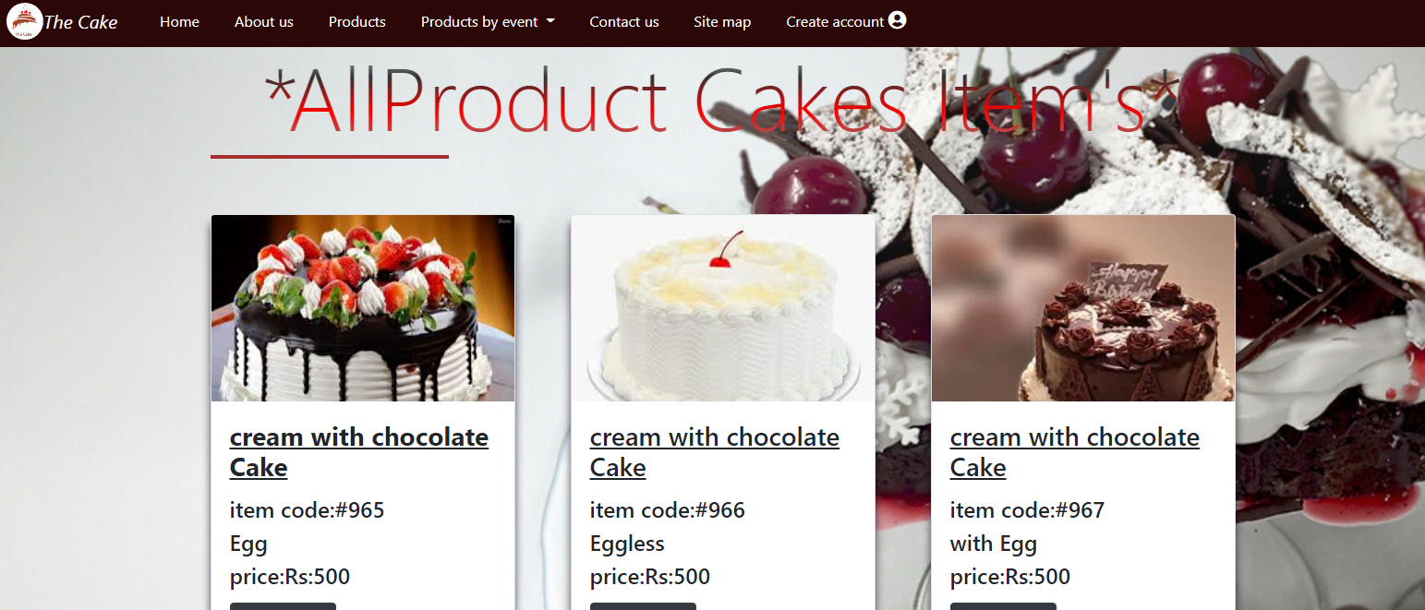

8.product details

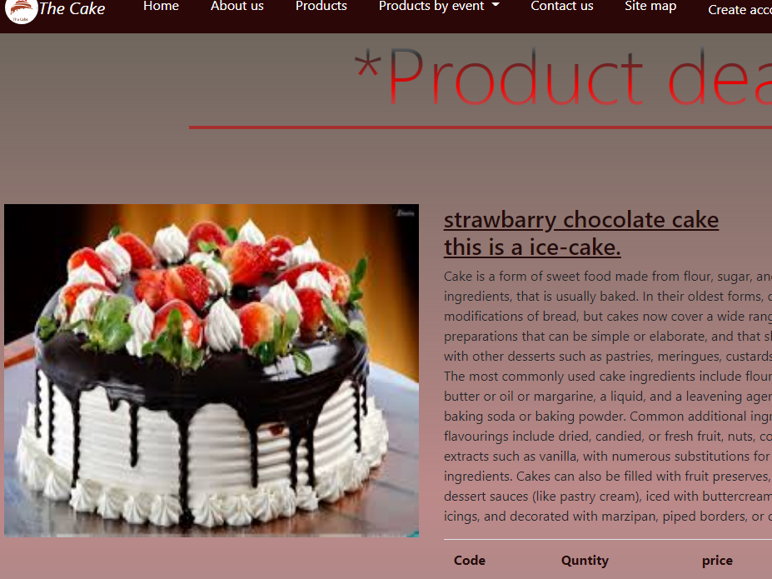

9. ANINARSARY ITEM



10. Birthday items

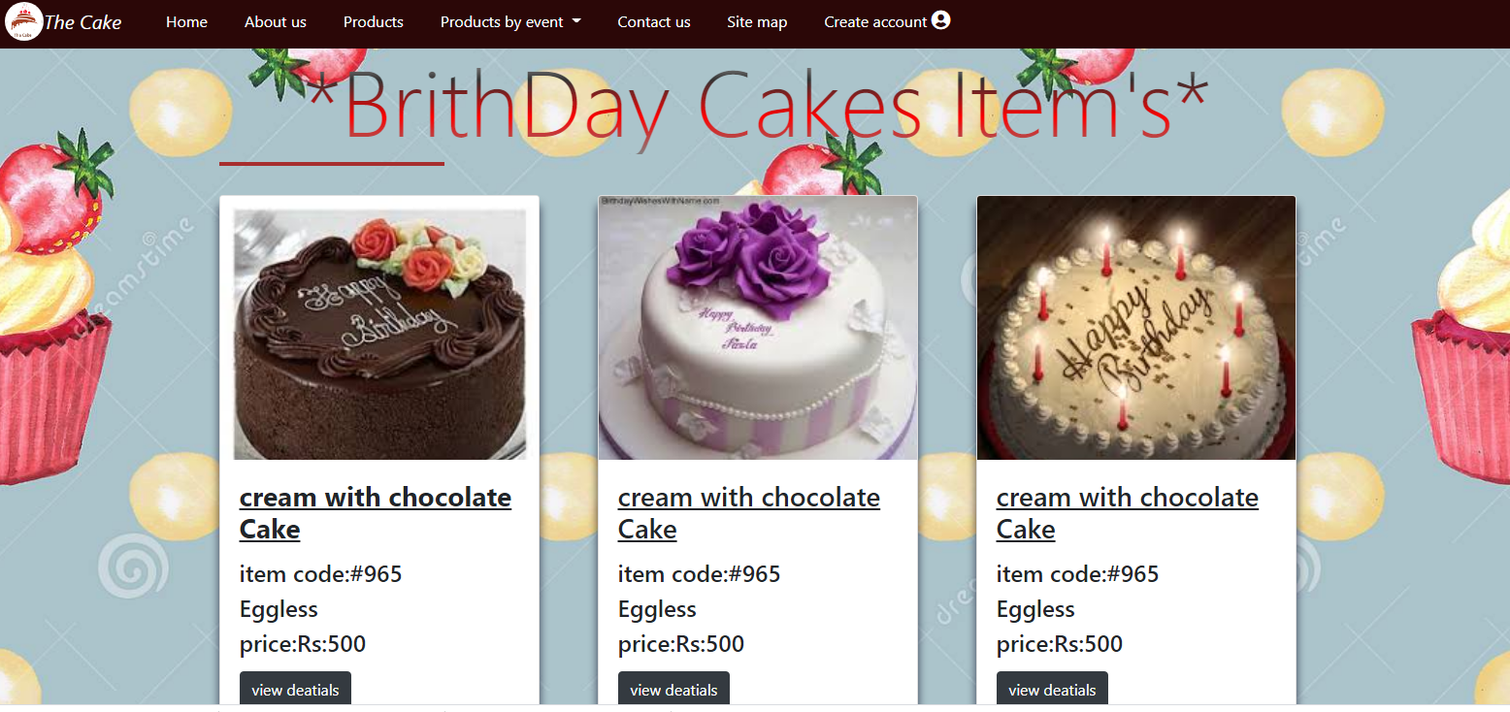

11.Engagement item

